Unix Assignment

- Assignment: Create & Manage Files
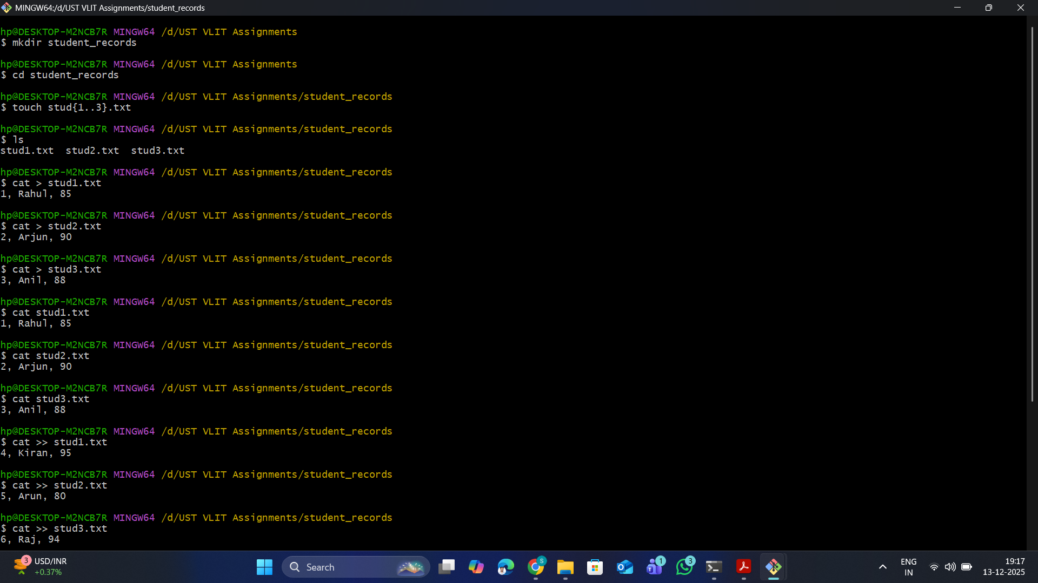

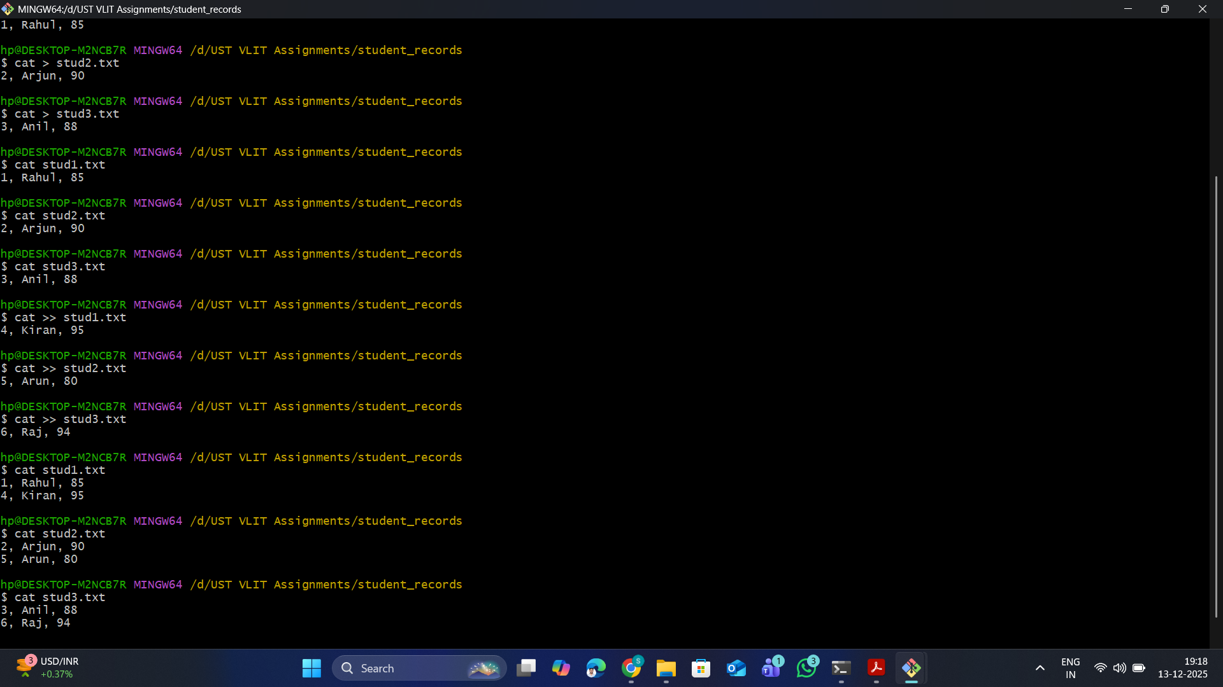

- Assignment: Working With Permissions
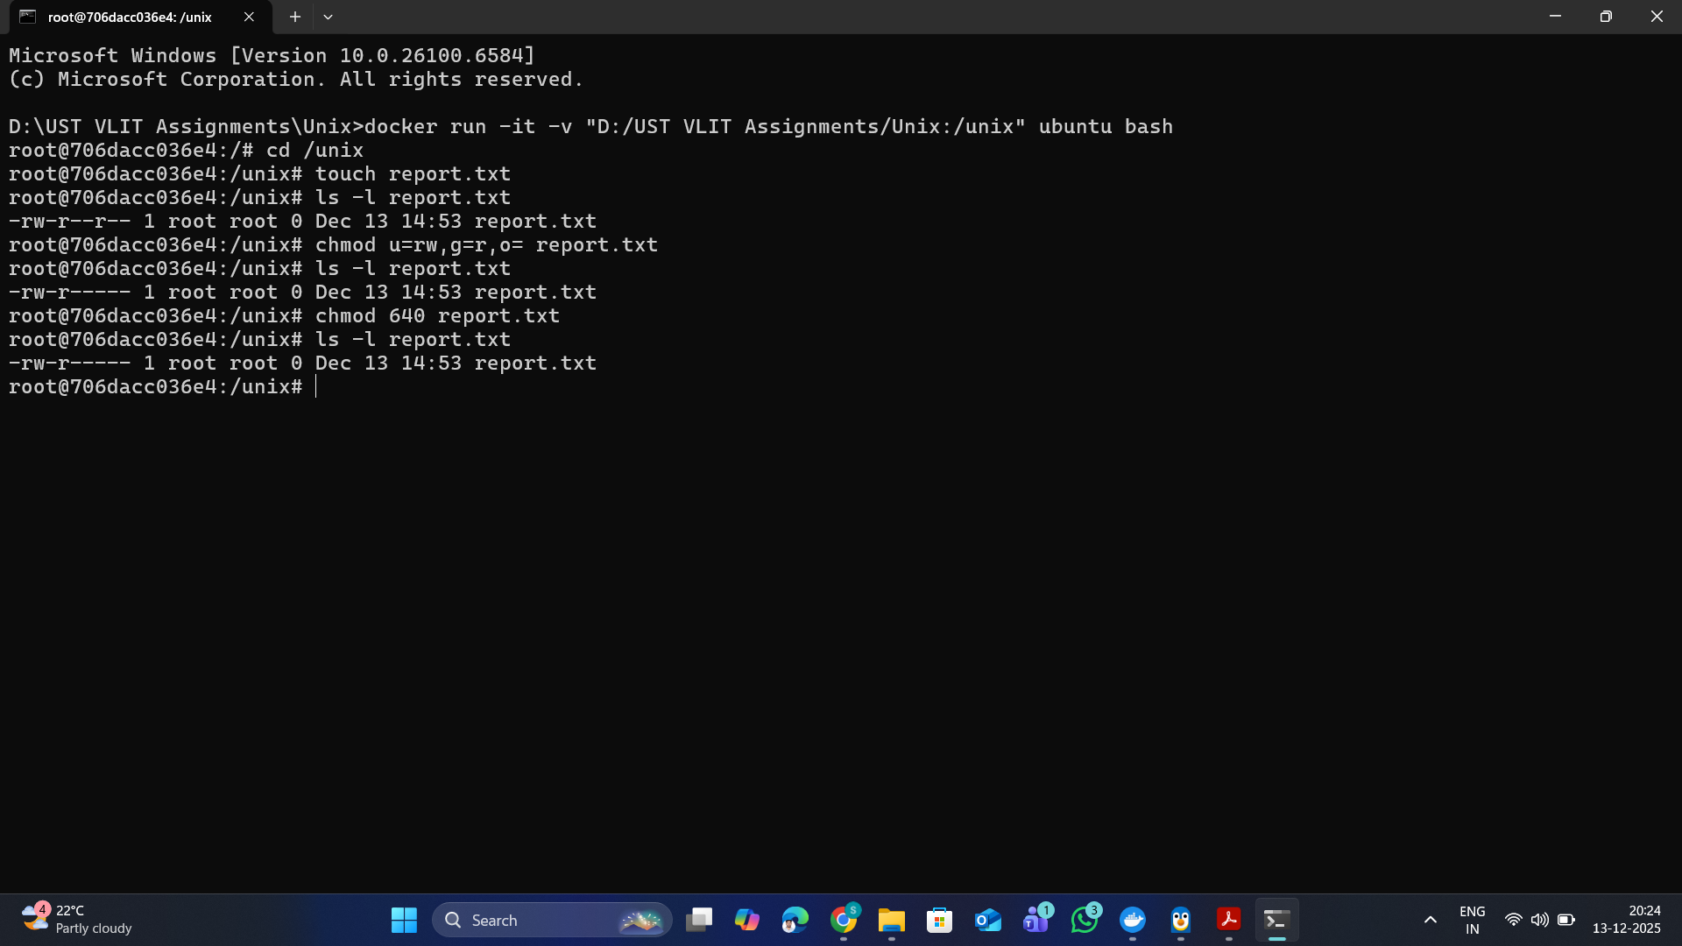

- Assignment: Shell Script – Simple Calculator
calc.sh :-
echo "Enter a number:"
read a

echo "Enter another number:"
read b

echo "Enter operator (+,-,*,/):"
read op

case $op in
+)
res=$((a + b))
;;
-)
res=$((a - b))
;;
\*)
res=$((a * b))
;;
/)
if [ $b -eq 0 ]; then
echo "Error: Division by zero"
exit 1
fi
res=$((a / b))
;;
*)
echo "Invalid operator"
exit 1
;;
esac

echo "Result: $res"

